Deprecated Functions
Incorporate Scan Procedure

Revision
Version 2
3/26/26 10:02 AM

SME
Charles Wilson

Abstract
This document describes the procedure used to perform the scan incorporation activity described in the AVCDL ^{[1]} secondary document Currently Used Deprecated Functions Document ^{[2]}.

Group / Owner
Development / Software Developer

Motivation
This document is motivated by the need to document and justify the use of deprecated functions in the development of software for use within safety-critical, cyber-physical systems.
Note: Within the context of this document, the terms security and cybersecurity are used interchangeably. It is presumed that the term security is being used in reference to cybersecurity and not physical security.

License
This work was created by Torc Robotics and is licensed under the Creative Commons Attribution-Share Alike (CC BY-SA-4.0) License.
https://creativecommons.org/licenses/by/4.0/legalcode

Audience
The audience of this document is the SME who will be incorporating the deprecated function scanning.

Completeness of Output
Since the incorporation of scanning for deprecated functions is an as-is analysis, it is critical to ensure that the information gathered is as accurate and complete as possible. All information should be sourced from and confirmed by the owner of the element under consideration.
When information is not available for either a given section of the template or parts thereof, this should be noted. Major omissions should be recorded in the cybersecurity risk register.

Disposition of Output
This activity does not create any output managed in the organization’s document management system (DMS) as a document of record.
Note: It is recognized that the updated build file is stored and managed within the context of the revision control system.

Entry Criteria
This document assumes that the reader understands the purpose of cybersecurity-relevant function deprecation. Further, that the reader has read and understood the Currently Used Deprecated Functions Document AVCDL secondary document.

Prerequisites – DevOps SME

Qualifications
It is required that the DevOps SME is both a qualified and trained with expertise in the build system used for the element under consideration in the context of the tooling necessary to perform deprecated function scanning.
Note: The specific qualifications and training necessary to assert specific expertise is outside the scope of this document.
Note: The DevOps group is responsible for determining and making available the appropriate SME for the modifications to the build system needed for the tooling under consideration.

Knowledge
It is required that the DevOps SME have expertise in the build system used for the element under consideration in the context of the tooling necessary to perform deprecated function scanning.

Prerequisites – Input Materials
It is required that the DevOps SME acquire all relevant documentation necessary to complete the procedure.

Incorporate Scan Activity
The workflow diagram for the incorporate scan activity of the deprecated functions process is shown below.
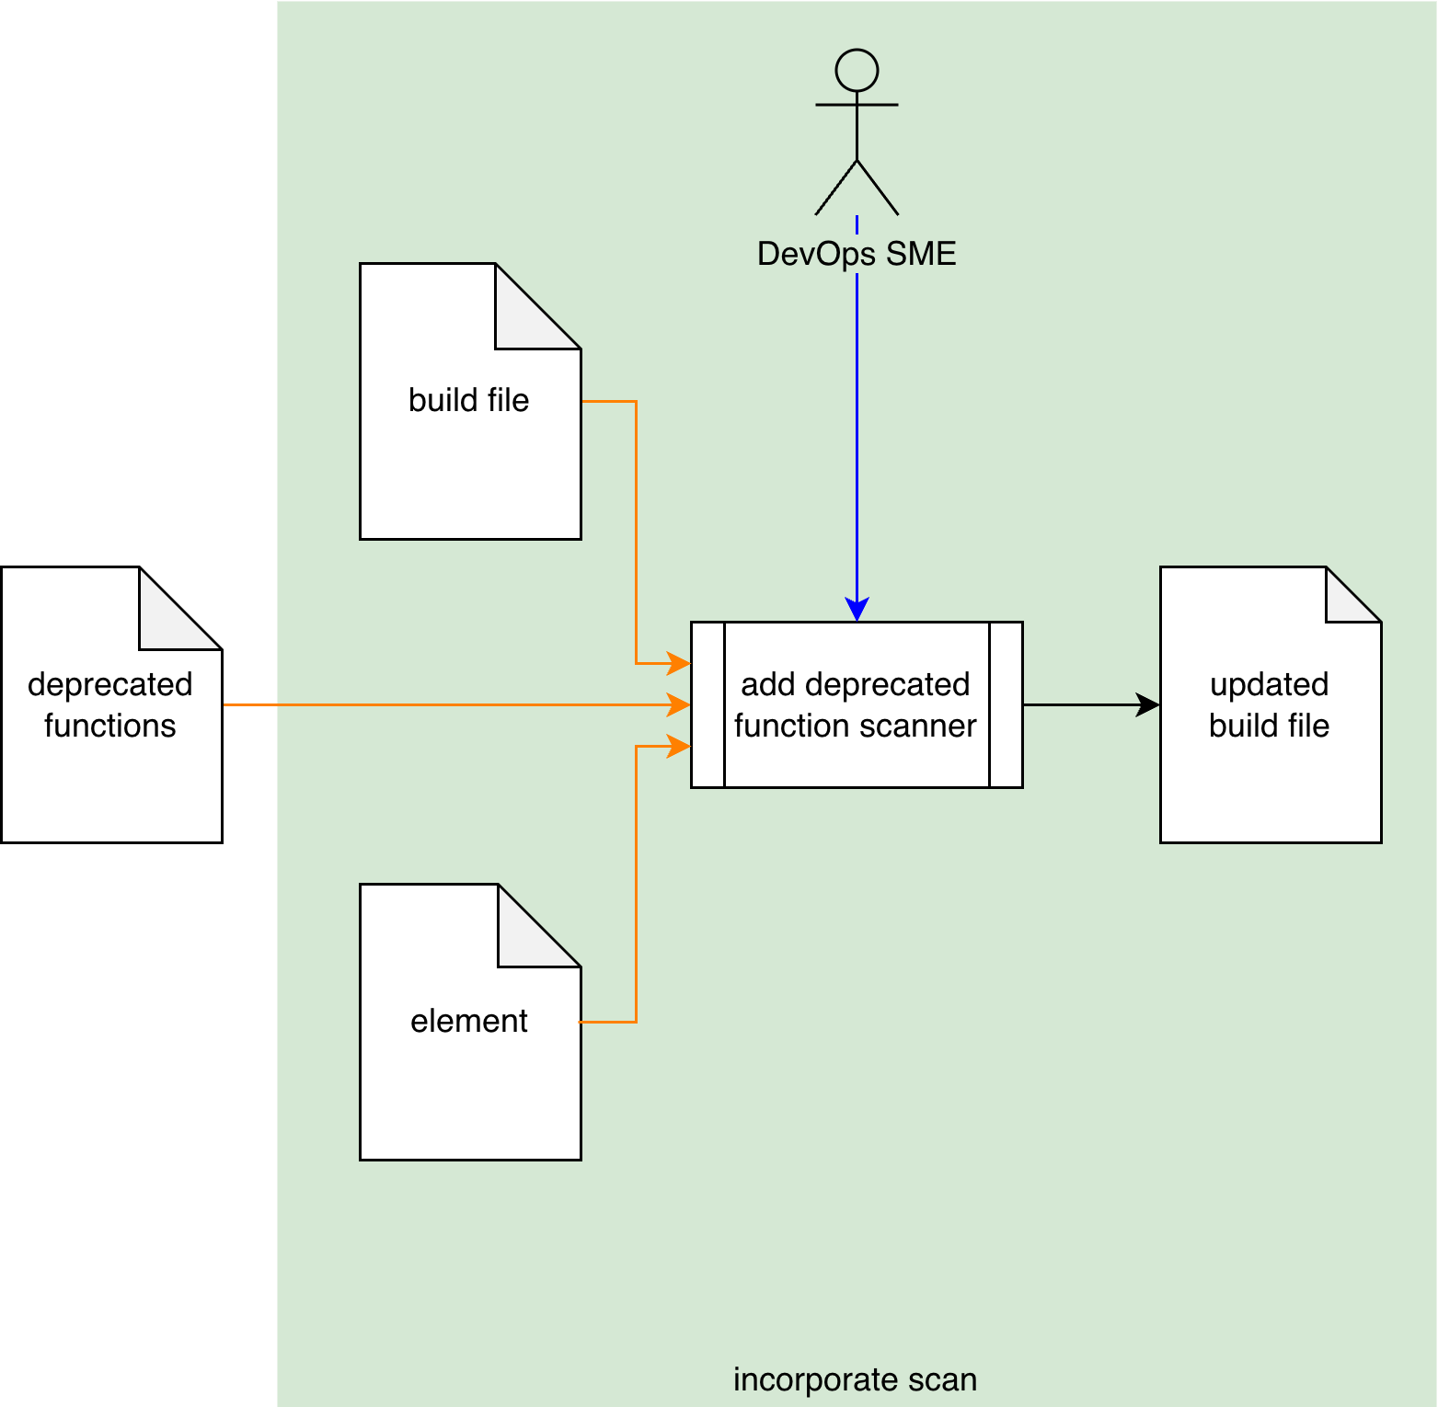
Using the Deprecated Functions list applicable to the Element, and Build File, the DevOps SME adds a function name scanner to the appropriate section of the Build File. An Updated Build File is created.

Methodology
The methodology to be used for incorporation of deprecated function scanning is straightforward. The DevOps SME modifies the build file for the element under consideration to incorporate a step that scans for the applicable deprecated functions. This function list is the output from the Identify Functions activity ^{[3]} and may be embodied as detailed in the AVCDL deprecated function catalog template ^{[4]}.
Note: Depending on the modifications made to the build file, there may be a negative impact on build process time. These impacts should be accounted for in any timing limiters applied to the build as a whole.
The specific means by which scanning is accomplished is determined by the organization’s tooling. Tooling options include, but are not limited to, static analyzers and shell scripts.
Note: Should there be an impact to tool settings, these should be implemented in alignment with the Secure Setting Document ^{[5]} AVCDL secondary document, specifically the Secure Settings – Apply Options Procedure ^{[6]} AVCDL tertiary document.

Scanning Tool Capabilities
The scanning tooling should minimally report the location of the deprecated functions from the provided list. If possible, references to the source of the deprecation, and recommended replacement should be provided.

Exit Criteria
This procedure is considered complete once the updated build file has been created and validated.
Note: It is recognized that the updated build file is stored and managed within the context of the revision control system.

References
- AVCDL (AVCDL primary document)
- Currently Used Deprecated Functions Document (AVCDL secondary document)
- Deprecated Functions Identify Functions Procedure (AVCDL tertiary document)
- AVCDL deprecated function catalog template (AVCDL template)
- Secure Settings Document (AVCDL secondary document)
- Secure Settings – Apply Options Procedure (AVCDL tertiary document)

